Fingerprint Bank Locker

The fingerprint based bank locker system is an enhancement to the traditional bank locker system that uses keys.
Now keys can easily be copied and made by theives who know about it. Also the keys must be taken care of and can also be lost due to some negligence.
Well fingerprint based bank locker system is here to solve all these issues.
The fingerprinted authenticated bank locker system is safe as well as easy to use and maintain.
No key handling no need to worry about key getting lost. The system uses fingerprint sensing to read fingerprints and first store registered fingerprints against the bank locker record. Now next time a person scans finger the sensor reads it and compares it with past records.
Now if match is found with existing prints, it sends the match signal to the microcontroller and the controller displays this data on the LCD display.
Also the controller drives the driver motor to open the bank locker door and opens it for authorized customers.
The door of locker want open for unauthorized customers.

Block Diagram :

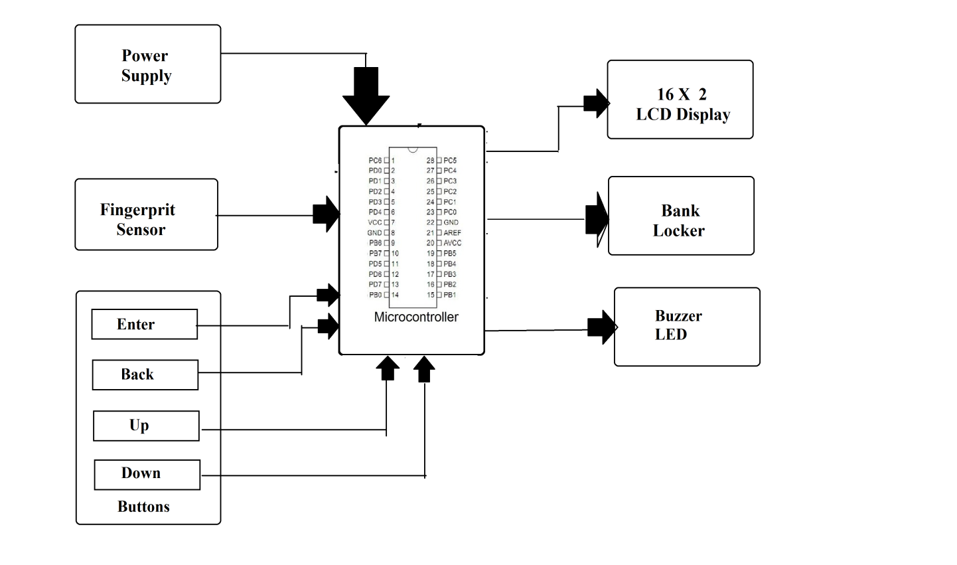

Hardware Specifications :
- Fingerprint Sensor
- Atmega 328 Microcontroller
- LCD Display
- Buzzer
- LED
- Bank Locker Door
- 12V Transformer
- Resistors
- Capacitors
- Diodes
Software Specifications

- Arduino Compiler

- MC Programming Language: C

